# ROBODODGE GAME

**Uml Diagram:**

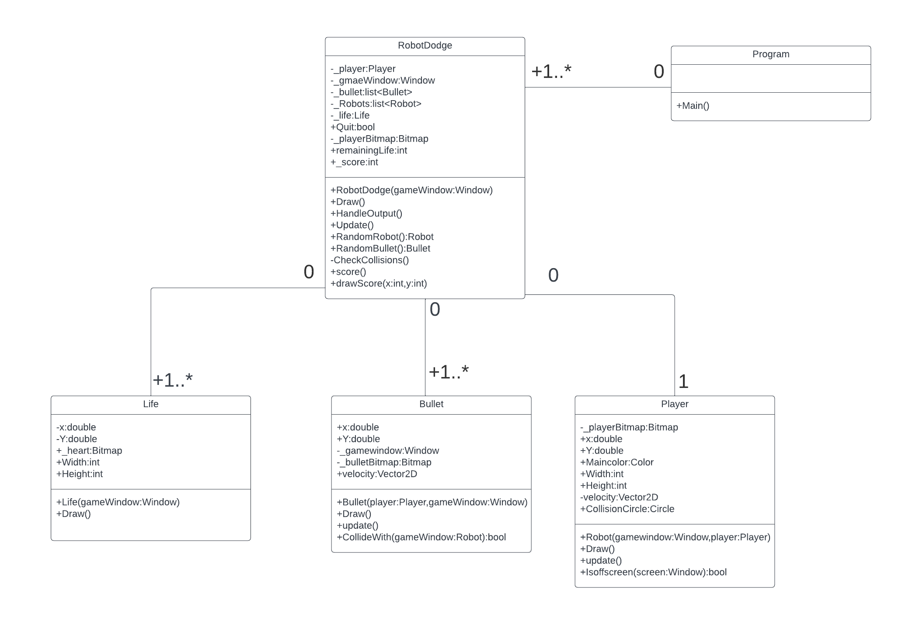

**Modeling Bullets:**

The Bullet class is responsible for modeling the bullets in the game. When a player shoots, a new instance of the Bullet class is created. The bullet's initial position is set to the player's position, and its velocity is calculated based on the direction from the player to the mouse cursor. This ensures that bullets move towards the cursor when fired.

**Bullet Movement:**

Bullets move continuously in the game window by updating their positions in the Update() method. The velocity vector determines the bullet's movement direction and speed. This allows bullets to traverse the game window until they collide with an object or move out of bounds.

**Bullet-Player Interaction:**

Bullets are initiated by the RoboDodge using the RandomBullet() method. The bullet's velocity is calculated based on the player's position and the mouse cursor's position. This ensures that bullets are fired in the direction of the mouse cursor.

**Bullet-Robot Interaction:**

The CollidedWith(Robot gameWindow) method checks for collision between a bullet and a robot. The collision is determined using a circle collision detection method with the robot's collision circle. Upon collision, the robot is marked as destroyed.